**Abdelfatah TAOUALA**

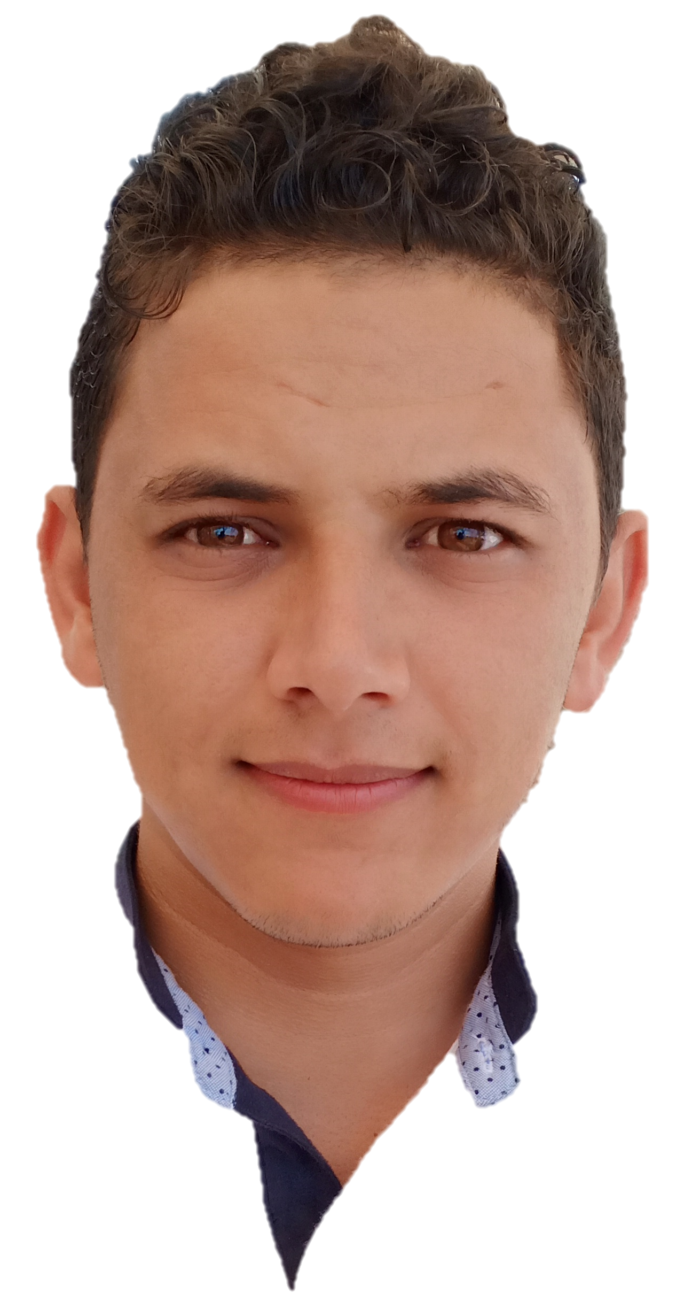

[Abdotaouala@gmail.com](mailto:Abdotaouala@gmail.com)

+21252637020

Casablanca, MOROCCO

Full-stack developer

**ReactJs - Angular - Spring**

Professional experience

April 2019 - Present 2019 : **Full-stack developer (ReactJS // Spring).**

Company : Maltem Consulting Group external at BCP Bank

Projects : ‘MaRetraite’ new simulator and manager savings contracts for the ChaabiNet platform (<https://bpnet.gbp.ma/>).

* Development of web interfaces and consumption of REST APIs in Front-end (React, PrimReact Thunk, Axios, Redux).
* Implementation of estimation calculation simulators based on insurance algorithms (JavaScript, Java 8)
* REST API development with spring boot.
* Implement back-end functions to manage the synchronization between our project and other chaabiNet projects (Java 8, RestTemplate).
* Management of the database with JPA / Hibernate, SQL / PLSQL
* Unit testing with JUnit and Mockito, EnzymeJs.
* Code reviews / Technical reference.
* Continuous Integration, Continuous Deployment with GitLab CI / CD.

Sector : Banking / Insurance.

Tools : ReactJs, Redux, Spring, Java 8, GitFlow, GitLab, Jenkins, Scrum/Agile, GitLab CI / CD, SonarLint.

July 2018 - April 2019 : **Full-stack developer** **(Angular // Spring).**

Company : Berexia Consulting external at Scor

Projects: FDC (Flexible Data Capture) advanced calculator estimates for the reimbursement of bodily injury.

* Development of web interfaces and consumption of REST APIs in Front-end (Angular, PrimeNg, Materialize, Bootstrap, Redux NgXs).
* Implementation of estimation calculation simulators based on insurance algorithms (TypeScript, Java 8)
* REST API development with spring boot
* Management of the database with JPA / Hibernate, SQL / PLSQL, continuous integration with DropOps.
* Unit testing with JUnit and Mockito, JasmineJs.
* Continuous Integration, Continuous Deployment with Jenkins.

Sector :Insurance

Tools : Angular, Redux, Spring, Java 8, Jenkins.

January 2018 - July 2019 : **Front-end Developer (Angular // DeepStrem // FireBase)**

Company : DevCorp external at SJL Group

Projetcs : Front office of OnTrack is a modern Transport Management

System

* Development of web interfaces and consumption of REST APIs in Front-end (Angular, PrimeNg, Bootstrap).
* Integrate real-time maps for manage vehicle location in real-time (DeepStream, FireBase).
* Unit testing JasmineJs.
* Versioning and code quality Git, GitHub, GitFlow, TsLint.

Sector : Transport / Logistics

Tools : Angular, DeepStream, Firebase, AmChart, google map.

January 2016 - July 2017 : **Front-end developer (ReactJs // HTML // CSS // Bootstrap)**

Company : Amaynotech external at Hightof

Projects : Front office to handle the tennis ball thrower HihgtTof (<https://www.youtube.com/watch?v=nnnvBSnAetg>)

* Development of web interfaces and consumption of REST APIs in Front-end (React, PrimeReact, RequestJs).
* Versioning and code quality Git, GitHub, GitFlow, SonarLint.

Sector : Sport

Tools : HTML, CSS, ReactJs, GitHub.

Computer skills

Front-end : Angular (1,2,4,6) , ReactJS.

Back-end Framework : Spring.

Realtime : DeepStream, Firebase.

Libraries : Google Map, Bootstrap, PrimeFaces, PrimeReact, AngularMaterialize, UnderScorJs, loadashJs.

Unit testing : Junit, Mockito, EnzimeJs, JasmineJS

Versioning : GIT, GitHub, GitLab.

code quality : SonarQube, SonarLint, TsLint, JsLint

Programing language : Java 8, TypeScript, JavaScript (ES5, ES6), SQL, PL/SQL.

DataBase : Oracle, SQL Server, MySQL, ElasticSearch, MongoDB.

DevOps Tools ; Jenkins, DropOps, GitLab CI / CD, Docker.

Education

2016 - 2018 : **Master Degree of Distributed IT Systems**

UNIVERSITY Hassan II Higher School of Technical Education OF

Mohammedia (MOROCCO).

2013 - 2016 : **BACHELOR OF technologies and web development.**

UNIVERSITY CADI AAYAD FACULTY OF SCIENCE SEMLALYA OF MARRAKECH (MOROCCO)